The Abstract Submission Deadline has been extended to 31 March 2026

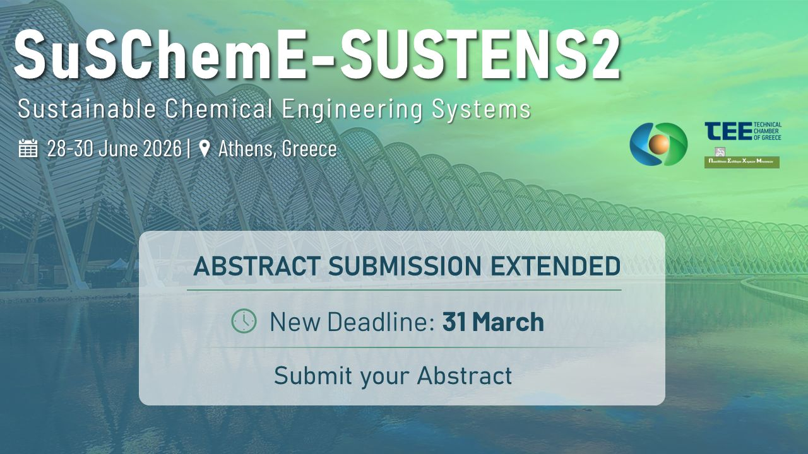
The organizing committee of the 1st Sustainability Section Conference (SuSChemE) has announced an extension of the abstract submission deadline for the upcoming event, which will take place 28–30 June 2026 in Athens, Greece.
Researchers and practitioners now have until 31 March 2026 to submit their abstracts and contribute to the conference program. The event is organized under the auspices of the European Federation of Chemical Engineering (EFCE) and co-hosted by SUSTENS2.
In addition, the conference programme has been extended by one additional day in order to accommodate the increased number of high-quality submissions and to ensure a well-balanced scientific schedule without parallel session overload. This adjustment allows for a more structured agenda, additional networking opportunities, and sufficient time for interactive discussions, workshops, and stakeholder meetings.
Participants will also have access to free-access hands-on workshops on AI, training sessions on sustainability software for LCA, and demonstrations of sustainable systems tools focused on industrial biotechnology applications, supported by IBISBA and its Greek hub IBISBA-GR.
Abstract Submission Deadline (extended): 31 March 2026
Don’t miss this final opportunity to share your research with the community.

